Teaching Physicians Not to Be Afraid of Poetry
Rafael Campo, MA, MD¹; Mark Doty²
Author Affiliations Article Information
JAMA. Published online September 27, 2018. doi:10.1001/jama.2018.13760

At the Ninth Annual Hippocrates Poetry and Medicine Symposium, convened in May 2018 at the Northwestern University Feinberg School of Medicine in Chicago, Illinois, physician-poet Rafael Campo, associate professor of medicine at Harvard Medical School, was joined in conversation by National Book Award–winning poet Mark Doty, distinguished professor of English at Rutgers University. An excerpted transcript of the first half of their dialogue follows—condensed and edited for clarity and concision. The second half of the dialogue appears in an accompanying Arts and Medicine article.
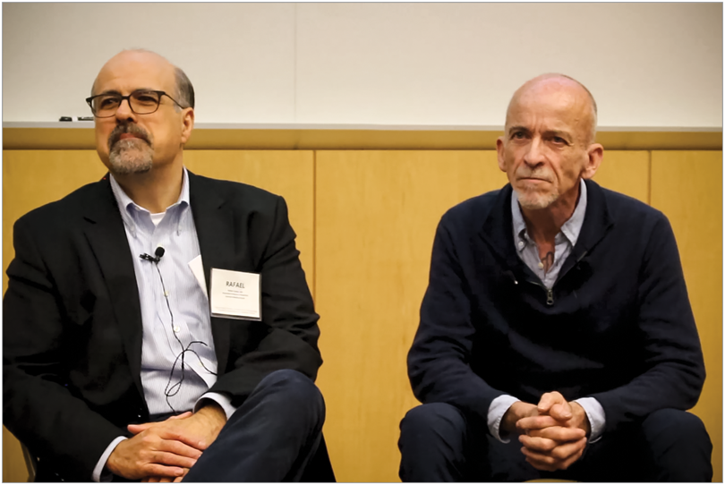
Rafael Campo and Mark Doty in conversation at the Ninth Annual Hippocrates Poetry and Medicine Symposium, May 11, 2018, at Northwestern University Feinberg School of Medicine in Chicago, Illinois.
Rafael Campo:We've been hearing this morning about the intersection between poetry and medicine. Doctors and care providers, more broadly, are supposed to be dispassionate objective scientists, and patients often are viewed as either burdened or weakened, or are in other ways distracted by the experience of illness. So why would either of these kinds of people be interested in poems?
Mark Doty:Here's an obvious place to start. We are bodies and we are equally stories. The intersection [between] our bodies and what is said about us is not fixed. I grew up hearing, for instance, that I wasn't the kind of boy who could fix things, know how to work on an engine, or change oil, and that story shaped the decisions I made as a young man. I grew to realize that if you don't tell your own story, somebody else will. I think that's very much in tune with the work [of] poetry, that we look at who we are and how we see ourselves and one another, and we start to recast the images—tell the stories in different ways.
RC:I had a similar experience growing up and feeling a sense of difference from those around me. Stories from my childhood were around the loss of the homeland, Cuba, and that wound drew me to healing through medicine [where] I could fix wounds in a more physical or literal sense. But it was through poetry, where the poem was a place of healing in a broader way, that I could tell those stories and revisit those injuries and make them whole again through the poem and through imagination.
MD:Poetry points toward that way in which the stories around us become our stories. They are imposed upon us or we take them in.
RC:We absorb them. And certainly illness, where the physical body betrays us, inscribes its own story, its own narrative in our bodies. [But] poetry has this wonderful visceral quality to it that's distinct from other sorts of narrative; how do you see that as figuring in to a use of poetry in the realm of medicine and healing?
MD:People who love [poems] use them as sorts of internal maps or orienting devices. In an internal landscape full of chaos and surprise, a poem becomes an anchoring place, a way of marking where you've been and considering where you are. The poem can become a kind of guiding image that might help you move through a difficult place.
RC:When I engage with some of my students around narrative and poetry, we think about metaphor as a way of moving or projecting ourselves through experience. And so maybe we could talk a little bit [about] that. Does poetry have some kind of relevance to the training of care providers—not just physicians but other healers?
MD:Absolutely. The poem is a place where we think about interiority and where we find a reflective individual experience crystallized or given to us in a pure and distilled form. You actually don't have to teach people to respond to poems. You have to teach people not to be afraid of them. By nature, we respond to imagery, to language that is shaped, to language that speaks to our own emotional lives. But you've got to get rid of those barriers of expectation: “I don't know how to read this because it doesn't go all the way to the end of the page” or “There's a secret meaning someone else knows and I do not.” You've got to throw that out to experience poetry in a more naive way.
RC:In medical training we're always expected to have the right answer, to think that there is a right answer. When we go to a poem, we must contend with the [fact] that there isn't necessarily a right answer. So getting past those kinds of inhibitions [to] this core truth that is accessible to us if we just allow ourselves to be vulnerable, to be present [is] in itself, I think, a valuable project for poetry in medical settings. We're so defended. We're so guarded. We have our white coats. We have our professional distance. We have our objectivity. We're armed with our science and our scientific studies. And those are interesting tensions that poetry can, I think, help defeat and help us question.
MD:I would think it would be difficult in medicine to say, “I look at the problems you're having and I don't know what's wrong with you.” It is much easier to look at a poem together and say “I don't know what that means,” but we can feel something there. And that not knowing together is one of best things human beings do, to dwell in uncertainty together. So poetry, by nature, invites us to not knowing, to beginning in uncertainty and confusion and stumbling our way out of bewilderment. Poet Stanley Kunitz used to say that if poetry teaches us anything at all, it's that we can believe two contradictory things at once. And that seems absolutely right to me that we can look at the same thing from two sides, and the poem is a kind of container for that sort of uncertainty.
RC:There are those moments in medicine where we don't know, [and] they're more frequent than we like to admit…those moments where there isn't another round of chemotherapy or another analgesic to take away the pain. What do we have in those moments to help our patients and to also, frankly, be present ourselves? That's what I think poetry can model for us.
MD:There’s really interesting research about the way that writing about a problem of any sort tends to promote healing. We get better faster if we make a narrative for ourselves of what's happened…Simply writing one's story is a way of containing it, of expecting change, of not allowing it to become overwhelming and unknowable, but creating a form, an experience. My first poetry teacher, a wonderful man named Richard Shelton, had a poem which contained the lines, “What we remember can be changed. What we forget, we are always.” And that has always seemed to me a very profound statement, that the stories, the incidents you can't remember or you don't give voice to, are in some way always in charge. The ones that you can remember, you can say, and when you say something, it may go away. Poetry does not cure trauma or dispel it, but it puts you in charge in some different way. You make a form for the experience and have some control over it; you give it a beginning, middle, end, you give it a meter. And you've made that thing which becomes a map, a place to stand. And because you have a place to stand, trauma [or illness] might do damage to you, but you have a room of your own, a space of your own.
RC:I think in medicine we appropriate the narrative—it’s our story, the story that we write in the charts, that the doctor tells, that becomes the important story. And so there's a kind of empowerment, I think, around authorship, when we return that story to the person who's living it, who's experiencing it, and invite them to be the expert. We have an initiative at my hospital called Open Notes where patients can actually write their own stories in the medical record, which is wonderful. And oftentimes my patients, since they know I’m crazy and interested in poetry, will write poems in response to their records.
MD:That's where that word authority gets really useful, you know. The author is the one who takes authority, who can tell the story, who has the authorized version of the story. In terms of health that could be very useful.

